ANALYTICAL METHODS DEVELOPMENT AND VALIDATION OF COMBINATION OF TWO DRUGS BY RP HIGH PERFORMANCE LIQUID CHROMATOGRAPHY
Pankaj Sharma1*, Dr. Rajesh Verma2, Dr.Pankaj Kumar Sharma3, Dr. Jaya Sharma4

1*Research Scholar, Department of Pharmacy, Apex University, Jaipur
2Prof. Department of Pharmacy, Apex University, Jaipur
3Dean (Pharmacy) Department of Pharmacy, Apex University, Jaipur
4Principal, Department of Pharmacy, Apex University, Jaipur

*Corresponding Author:

Abstract:
This research paper presents the development and validation of RP high-performance liquid chromatography (RP- HPLC) methods for the simultaneous estimation of drug combinations in marketed formulations. The study is divided into two sections, the first section describes the development and validation of an HPLC method for the simultaneous estimation of Sitagliptin & Simvastatin in marketed formulations. The second section focuses on the development and validation of an HPLC method for the simultaneous estimation of Amlodipine, HCTZ, and Valsartan in marketed formulations. Both HPLC methods undergo rigorous validation based on various parameters, including system suitability, specificity, linearity, limit of quantification (LOQ), and limit of detection (LOD). The validation results confirm the reliability and suitability of the developed methods for the simultaneous estimation of the respective drug combinations.

Keywords: RP-HPLC, Validation, LOD, LOQ

Introduction:
Amlodipine is a medication used as antihypertensive agent. The chemical name of Amlodipine is (RS)-3-ethyl5- methyl2-[(2-aminoethoxy)methyl]-4-(2-chlorophenyl)-6-methyl-1,4-dihydropyridine-3,5-dicarboxylate, with a molecular formula of C20H25ClN2O5 and a molecular weight of 408.879. The recommended dose is 5 to 10 mg. Amlodipine can have adverse effects or side effects. Some of the more common side effects include Swelling of the anklesor feet.

Fig 1: Amlodipine
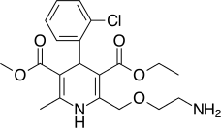

Valsartan is a medication used as antihypertensive agent. The chemical name of Valsartan is (S)-3-methyl-2-(N-{[2'- (2H-1,2,3,4-tetrazol-5-yl)biphenyl-4-yl]methyl}pentanamido)butanoic acid, with a molecular formula of C24H29N5O3 and a molecular weight of 435.519. The recommended dose is 40 mg. Valsartan can have adverse effects or side effects. Some of the less common side effects include Bloody urine, cold sweats, confusion and decreased frequency or amount of urine.

Fig 2: Valsartan
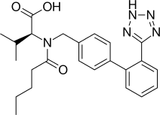
Hydrochlorothiazideis a medication used as antihypertensive agent. The chemical name of Hydrochlorothiazide is 6- chloro-1,1-dioxo-3,4-dihydro-2H-1,2,4-benzothiadiazine-7-sulfonamide, with a molecular formula of C7H8ClN3O4S2 and a molecular weight of 297.74. The recommended dose is 25mg to 100mg. Hydrochlorothiazide can have adverse effects or side effects. Abdominal discomfort, leg pain, stomach pain, bleeding gums, blistering, peeling, or loose skin, bloating, and nausea are only some of the usual adverse effects.

Fig 3: Hydrochlorothiazide
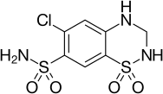
Simvastatinis a medication used as blood glucose lowering drugs. The chemical name of Simvastatin is (1S,3R,7S,8S,8aR)-8-{2-[(2R,4R)-4-hydroxy-6-oxotetrahydro-2H-pyran-2-yl]ethyl}-3,7-dimethyl-1,2,3,7,8,8a- hexahydronaphthalen-1-yl-2,2-dimethylbutanoate, with a molecular formula of C25H38O5 and a molecular weight of
418.56. The recommended dose is 5 - 40 mg orally once a day. Simvastatincan have adverse effects including dizziness, fainting and fast or irregular heartbeat.

Fig 4: Simvastatin
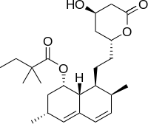

Sitagliptin is a medication used as a hypoglycemic agent in the treatment of diabetes. It has a molecular formula of C16H15F6N5O and a molecular weight of 407.31.The chemical name of sitagliptin is (R)-4-oxo-4-[3-(trifluoromethyl)- 5,6-dihydro[1,2,4]triazolo[4,3-a]pyrazin-7(8H)-yl]-1-(2,4,5-trifluorophenyl)butan-2-amine. Sitagliptin exerts its therapeutic effects by inhibiting the enzyme dipeptidyl peptidase-4 (DPP-4).While taking sitagliptin, individuals may experience certain side effects. These can include nausea.

Fig 5: Sitagliptin
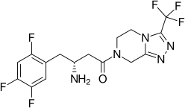

Experimental:
This paper is divided into two sections based on the research study. The first section deals with development and validation of HPLC method for the simultaneous estimation of Sitagliptin & Simvastatin in marketed formulations. The second section deals with Amlodipine, HCTZ and Valsartan for the same.

Methodology:
- Preparation of solutions: For Sitagliptin & Simvastatin:
  - Buffer solution:For Sitagliptin & Simvastatin, accurately measured 1.0 ml of Ortho phosphoric acid in a 1000 ml of volumetric flask, about 900 ml of HPLC grade water obtained from Milli-Q water purification system was added, sonicated and degassed and lastly fabricated the volume to 1000 ml with water.
For Amlodipine, Hydrochlorothiazide and Valsartan, accurately 1ml of Ortho Phosphoric Acid in a 1000ml of volumetric flask, add about 900ml of milli-Q water added and degas to sonicate and finally make up the volume with water.
  - Standard Stock Solution: For Sitagliptin & Simvastatin, perfectly weighed & transferred 25mg of Sitagliptin, 10mg of Simvastatin into a 25 ml and 100ml VF-volumetric flask respectively, add diluent to final volume. From this, 1 ml was pipette out to a 10 m1 volumetric f1ask & diluents added to obtain final volume.
For Amlodipine, Hydrochlorothiazide and Valsartan, accurately weighed and transferred 5mg of Amlodipine, 12.5mg of HCTZ and 160 mg of Valsartan working Standards into a 50 ml, clean dry volumetric flask, diluent was added, sonicated for 30 minutes and make up to the final volume with diluents. From the above stock solution, 1 ml was pipette out in to a 10ml volumetric flask and then make up to the final volume with diluents.
  - Working Standard Solutions: For Sitagliptin & Simvastatin, 0.25, 0.5, 0.75, l.0, l.25 & l.5 m1 were pipetted out from stock solution & shifted to l0 ml volumetric flask & volume was filled up to l0 ml with diluent. This gives solutions οf 25, 50, 75, 100, 125, 150 micro gm/ml for Sitagliptin and 2.5, 5.0, 7.5, l0.0, l2.5, l5.0 microgm/ml for Simvastatin respectively.
For Amlodipine, Hydrochlorothiazide and Valsartan, Aliquots of 0.25,0.5, 0.75, 1.0,1.25 & 1.5 ml were pipetted out from the stock solution and transferred into a 10 ml volumetric flask and volume was made up to 10 ml with diluent.

This gives the solutions of 2.5, 5.0, 7.5, 10.0, 12.5, 15.0 µg/ml for Amlodipine and 6.25, 12.5, 18.75, 25.0, 31.25, 37.50
µg/ml for HCTZ and 80, 160, 240, 320, 400, 480 µg/ml Valsartan, respectively.

  - Sample preparation:For Sitagliptin & Simvastatin, 1 tablet was weighed and powdered and it was taken into a 100 ml volumetric flask – VF and filled with diluents. This was filtered by HPLC filters.1ml of filtered sample stock solution was transferred to 10ml volumetric flask and made up with diluents.
For Amlodipine, Hydrochlorothiazide and Valsartan,20 tablets were weighed and powdered and it was taken into a 50ml volumetric flask and made up with diluents and labeled as Sample stock solution. Sample stock solution was filtered by HPLC filters.1ml of filtered sample stock solution was transferred to 10ml volumetric flask and made up with diluents.

- Chromatographic conditions: The chromatographic separation was achieved by injecting a volume of 10μl of standard into BDS (250mm x 4.6 mm, 5 ). The mobile phase of composition Buffer and Acetonitrile taken in the ratio 73:27A were allowed to flow through the column at a flow rate of 1.2 ml/min for a period of 7 minutes at a wavelength of 212nm. The retention times (RT) were found at 2.4 and 3.0 minutes for Metformin & Sitagliptin respectively.

- Method Validation: System suitability, Specificity, linearity, accuracy, LOQ, LODwere evaluated.

Table 1: Specificity data of Sitagliptin & Simvastatin
 | Average standard area | Standard deviation | RSD%
Sitagliptin | 768022 | 4939.6 | 0.6
Simvastatin | 174191 | 1573 | 0.9

Table 2: Specificity data of Amlodipine, Hydrochlorothiazide and Valsartan
 | Average standard area | Standard deviation | RSD%
Amlodipine | 109574 | 733.96 | 0.67
Hydrochlorothiazide | 647833 | 2659.7 | 0.4
Valsartan | 215572 | 13463 | 0.6

Fig 6: Optimized chromatogram of Sitagliptin & Simvastatin
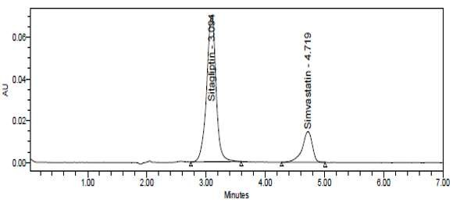

Table 3: Optimized chromatographic conditions of Sitagliptin & Simvastatin
S. Nο. | Systems | Values
1 | Mobile phase mix | Buffer, Acetonitrile and methanol taken in the ratio 20:70:l0A
2 | pH | 3.3
3 | Column, make | BDS column (4.6 x l50mm, 5μm)
4 | Column temperature | 30°C
5 | Wave 1ength | 215nm
6 | Injection volume | 10μ1
7 | Flow rate | l.0m1/min
8 | Run time | 07 min
9 | Retention time(Sitagliptin) | 3.1 min
10 | Retention time(Simvastatin) | 4.7 min

Fig7: Optimized chromatogram of Amlodipine, Hydrochlorothiazide and Valsartan
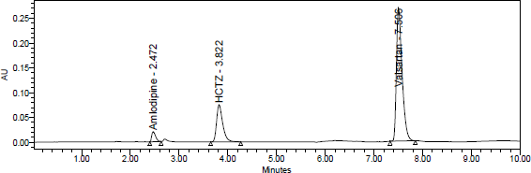

Table 4: Optimized chromatographic conditions of Amlodipine, Hydrochlorothiazide and Valsartan
S. No. | Parameter | Condition
1 | Mobile phase | Buffer and Acetonitrile taken in the ratio 55:45A
2 | pH | 3.3
3 | Column, make | Inertsil ODS (250mm x 4.6 mm,
4 | Column temperature | 30°C
5 | Wave length | 270 nm
6 | Run time | 10 min
7 | Injection volume | 10 μl
8 | Flow rate | 1.0ml/min
9 | Retention time(Amlodipine | 2.4 min
10 | Retention time(HCTZ) | 3.8 min
11 | Retention time(Valsartan) | 7.5 min

Table 5: Repeatability of Sitagliptin & Simvastatin
 | Sitagliptin | Simvastatin
Repeatability (RSD%) | 0.6 | 1.2

Table 6: Repeatability of Amlodipine, Hydrochlorothiazide and Valsartan
 | Amlodipine | Hydrochlorothiazide | Valsartan
Repeatability (RSD%) | 1.9 | 0.9 | 0.7

Table 7: Recovery data for Sitagliptin & Simvastatin
 | Sitagliptin | Simvastatin
% Recovered (RSD%) | 0.61 | 1.06
% Recovery | 100.94 | 102.42%

Table 8: Recovery data forAmlodipine, Hydrochlorothiazide and Valsartan
 | Amlodipine | Hydrochlorothiazide | Valsartan
% Recovered (RSD%) | 1.15 | 1.05 | 0.90
% Recovery | 100.53 | 100.29 | 100.01

Table 9: Results of LOD and LOQ of Sitagliptin & Simvastatin
 | LOD (𝜇g/mL) | LOQ (𝜇g/mL)
Sitagliptin | 0.18 | 0.55
Simvastatin | 0.03 | 0.10

Table 10: Results of LOD and LOQ of Amlodipine, Hydrochlorothiazide and Valsartan
 | LOD (𝜇g/mL) | LOQ (𝜇g/mL)
Amlodipine | 0.09 | 0.28
Hydrochlorothiazide | 0.35 | 1.08
Valsartan | 0.19 | 0.57

Fig8: Linearity plot of Sitagliptin & Simvastatin
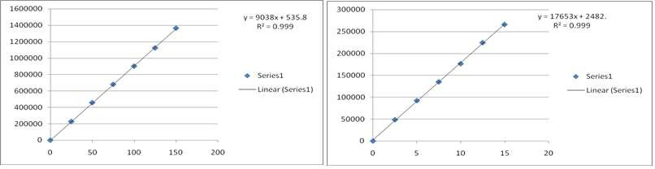

Fig9: Linearity plot of Amlodipine, Hydrochlorothiazide and Valsartan
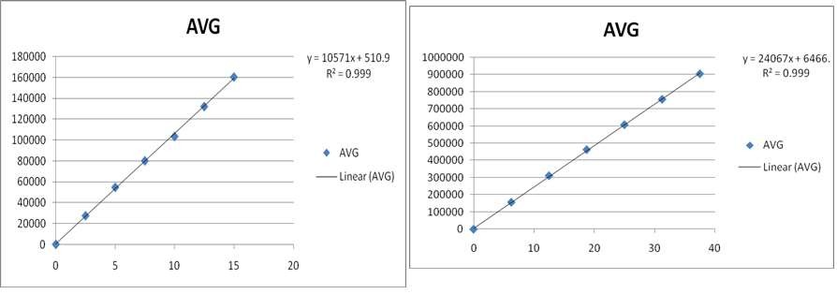

Table 11: System suitability parameters for Sitagliptin & Simvastatin
Parameters | Sitagliptin | Simvastatin
Retention times | 3.1min | 4.7min
Theoretical plates | 2285 | 4301
USP tailing | 1.01 | 1.02

Table 12: System suitability parameters forAmlodipine, Hydrochlorothiazide and Valsartan
Parameters | Amlodipine | Hydrochlorothiazide | Valsartan
Retention times | 2.4 min | 3.8 min | 7.5 min
Theoretical plates | 4324 | 4667 | 19526
USP tailing | 1.44 | 1.41 | 1.56

Results and Discussion:
The retention times of Sitagliptin & Simvastatin were found to be 3.1min & 4.7min, respectively. Number of theoretical plates were 2285 and4301, USP tailing were 1.01,1.02 for Sitagliptin & Simvastatin, respectively; this showed optimized method met the system suitability parameters. The percentage mean recovery of Sitagliptin & Simvastatin was found to be 100.94, and 102.42%, respectively. The lowest values of LOD and LOQ were 0.18 and 0.55μg/ml; 0.03 and 0.10μg/ml for Sitagliptin & Simvastatin, respectively.

The retention times of Amlodipine, HCTZ and Valsartan were found to be 2.4 min, 3.8 min & 7.5 min, respectively. Number of theoretical plates were 4324, 4667 and 19526, USP tailing were 1.44, 1.41and 1.56; this showed optimized method met the system suitabilityparameters. The percentage mean recovery of Amlodipine, HCTZ & Valsartan were found to be100.53, 100.29 and 100.01%, respectively. The lowest values of LOD and LOQ were 0.09 and 0.28μg/ml;
0.35 and 1.08μg/ml; 0.19 and 0.57μg/ml for Amlodipine, HCTZ and Valsartan, respectively.

References:
- Ahmad, Sufiyan & Sajjad, Ansari & Md. Usman, & Imran, Mohammed & Akhtar, Rashid. (2017). Development and Validation of RP-HPLC Method for Simultaneous Estimation of Metformin and Miglitol in Bulk and Dosage Form. Asian Journal of Pharmaceutical Research. 7. 139. 10.5958/2231-5691.2017.00022.3.
- Amulya, E. & Kumar, N. & Mounika, CH &Kowmudi, V. & Supriya, N. & Madhur, K.. (2018). Development and Validation of RP-HPLC Method for the Simultaneous Estimation of Haloperidol and Trihexy-phenidyl in API and Combined Tablet Dosage Form. International Journal of Applied Pharmaceutical Sciences and Research. 3. 10.21477/ijapsr.3.3.3.

- Azim, Md &Moloy, Mitra & Bhasin, Parminder. (2015). HPLC method development and validation: a review. International Research Journal of Pharmacy. 4. 39-46. 10.7897/2230-8407.04407.
- Bbv, Sailaja & Veditha, K.. (2018). Analytical method development and validation for simultaneous estimation of nebivolol and valsartan in tablet dosage form by RP-HPLC. Journal of Global Pharma Technology. 10. 6-14.
- Bhardwaj, H., Goyal, R., & Agarwal, D. (2020). Method Development and Validation for Simultaneous Estimation of Pharmaceutical Dosage Form by HPLC. Asian Journal of Pharmaceutical Research and Development, 8(4), 137- 147.
- Chettupalli, Ananda & Thumma, Gouthami & Boggula, Narender & B, Vasudha. (2018). Method Development and Validation for the Simultaneous Analysis of Duloxetine HCL and Methylcobalamine by RP-HPLC. International Journal of Pharmaceutical Quality Assurance. 9. 10.25258/ijpqa.v9i4.14534.
- Fatima, Anab. (2014). Development and validation of RP-HPLC method for simultaneous determination of Amoxicillin and Ranitidine in pharmaceutical formulations. World Journal of Pharmaceutical Research. 3. 1662- 1671.
- Gholve, Sachin &Gangapure, Sharddha&Birajdar, Mahesh &Mujewar, Imran &Bhusnure, Dr. Omprakash. (2019). RP-HPLC Method Development and Validation for Determination of Didanosine in Pharmaceutical Dosage Forms. Journal of Drug Delivery and Therapeutics. 9. 343-347. 10.22270/jddt.v9i4-s.3328.
- Jain, Priyanka &Rajoriya, Vaibhav &Kashaw, Varsha. (2015). Development and Validation of Simultaneous RP- HPLC Method for the Estimation of Theophylline and Motelukast in Pharmaceutical Formulation. Analytical Chemistry Letters. 5. 172-182. 10.1080/22297928.2015.1102645.
- Kumar, Y & Priyadarshini, Gayatri & Sirisha, Y. (2018). Stability indicating RP-HPLC method development and validation for the simultaneous estimation of cefixime and paracetamol in bulk and pharmaceutical dosage form. International Research Journal Of Pharmacy. 9. 90-94. 10.7897/2230-8407.09234.
- Kumaraswamy. Gandla, R. Lalitha, Sadhana.Bommakanti, R. Suthakaran, K. Pallavi. Development and Validation of RP-HPLC Method for Simultaneous Estimation of Albendazole and Praziqantel in Tablet Dosage Form. Asian J. Pharm. Ana. 5(3): July- Sept. 2015; Page 115-118.
- Monika Maheshwari, Parul Soni. RP-HPLC Method development and Validation for Rapid estimation of Diazepam in Bulk and Pharmaceutical Dosage Form. Research Journal of Pharmacy and Technology. 2022; 15(5):1938-2.
- More, Sayali & Sonawane, Sandeep &Chhajed, Santosh & Kshirsagar, Sanjay. (2018). Development and Validation of RP-HPLC Method for Simultaneous Estimation of Saxagliptin and Dapagliflozin in Tablets. Asian Journal of Pharmacy and Technology. 8. 145. 10.5958/2231-5713.2018.00023.5.
- Patel, Bhoomi & Bhavya, Mehta & Chaudhary, Ankit. (2020). Method development and validation for simultaneous estimation of lamivudine and zidovudine in tablet by reverse-phase high-performance liquid chromatography. Asian Journal of Pharmaceutical and Clinical Research. 73-77. 10.22159/ajpcr.2020.v13i6.37288.
- Rani, K. & Kumar, P.Bharath & Priya, R. & Sekhar, K.B.. (2015). A new RP-HPLC method development and validation for simultaneous estimation of lamotrigine and zonisamide in pharmaceutical tablet dosage formulations. 6. 139-144.
- Reddy, G. & Kumar, S. & Debnath, Manidipa & Kumar, V.. (2014). Analytical method development & validation for simultaneous determination of Dutasteride and Tamsulosin in bulk as well as in pharmaceutical dosage form by using RP-HPLC. International Journal of Pharmacy and Pharmaceutical Sciences. 6. 77-84.
- Salkar, Sayali. (2017). RP-HPLC method development and validation for simultaneous estimation of silibinin and ursodeoxycholic acid in bulk and in their combined tablet dosage form. World Journal of Pharmaceutical Research. 811-819. 10.20959/wjpr20176-8503.
- Vani, Preeti & Kottapalli, K.S.. (2011). Development and validation of RP-HPLC method for simultaneous estimation of naproxen and Esomeprazole in pharmaceutical dosage form. International Journal of Pharmacy and Technology. 3. 3446-3455.
- Younus, Mohammad & Pasha, s.Imam& Siddiq, M. & Lakshmi, A.P.. (2013). RP HPLC method development and validation for estimatation of isradipine in tablet dosage form. Asian Journal of Pharmaceutical and Clinical Research. 6. 140-142.

